**Usage metrics report credentials**

**Introduction**

The usage metric report needs a dataset that's updated daily and relies on valid credentials for refreshing.

As a data analyst, you must know how to renew your credentials to keep your access to important metrics uninterrupted.

In this reading, you’ll learn about the importance of maintaining credentials and the process for updating credentials.

**Scenario**

Lucas manages the 'Adventure Works Sales' workspace in Power BI, which includes important sales reports and the usage metrics report. He needs to switch the dataset's credentials to be controlled by the admin account.

**Usage metric report dataset**

Let's examine the details of a usage metric report dataset.

Power BI automatically generates this dataset when users create a usage metric report within the workspace.

It comes with a fixed daily refresh schedule that can't be changed. To refresh, it requires workspace permissions, so Power BI designates the report's creator as the dataset owner.

**Scheduled refresh issues**

This process gives rise to one key problem: User credentials can expire. This causes the daily dataset refresh for the usage metric report to stop.

This occurs when:

* Credentials expire.
* You remove the report's creator from the workspace.
* Or the report's creator leaves the organization.

In each case, you must update the credentials to restart the daily refresh.

**Updating usage metrics report credentials**

A new user must log in as the new dataset owner to update credentials for a usage metrics report dataset.

Let’s explore this process in the **Adventure Works Sales** workspace in Power BI. This workspace includes important sales and usage metrics reports. The dataset's credentials must be switched so that the admin account controls them.

1. Access the settings for any report in your workspace and select **View usage metrics report**.

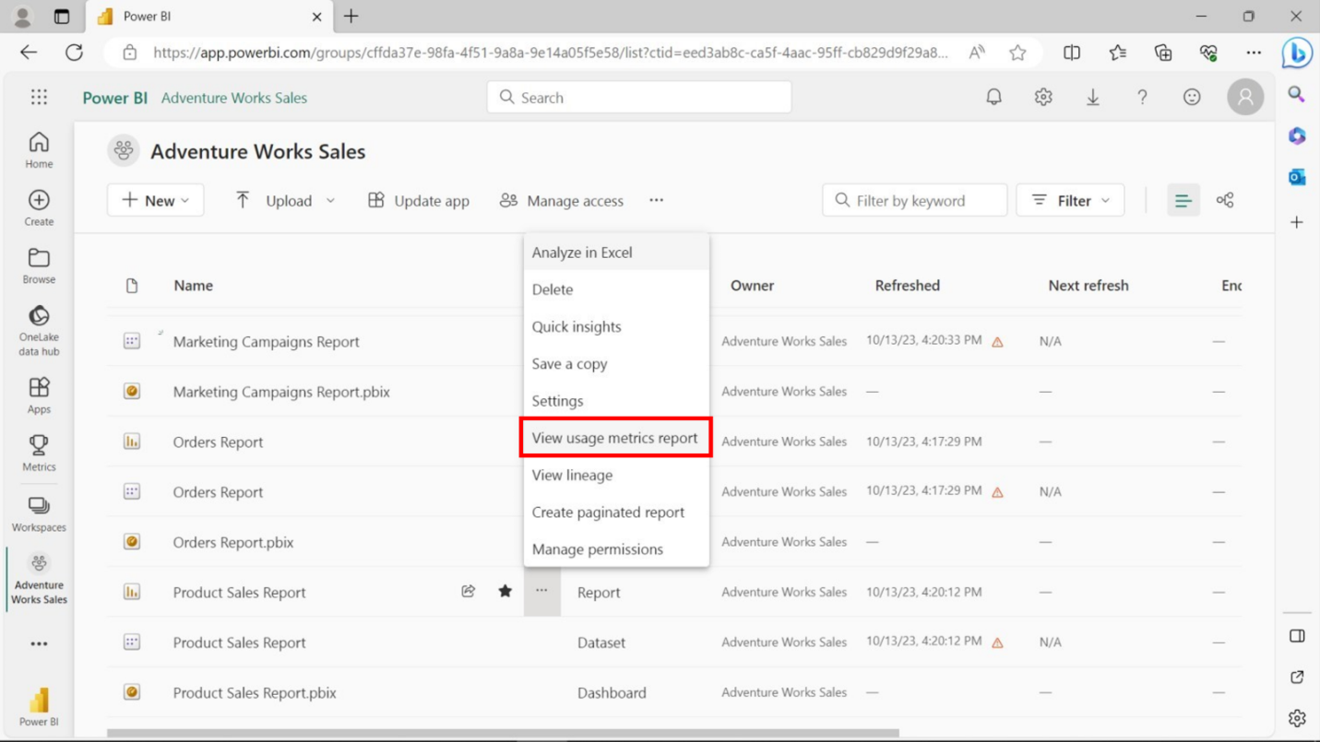

1. On the usage metrics report, select the ellipsis above the report, and select **View dataset**.

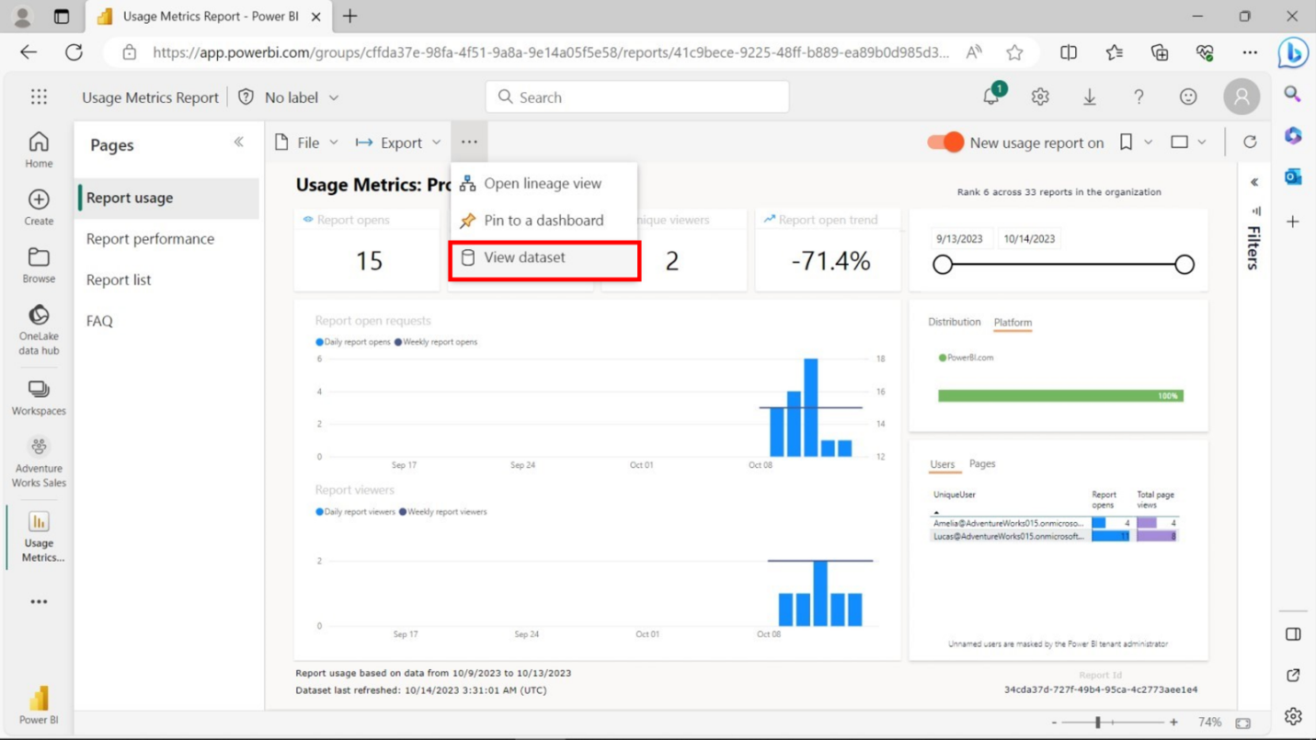

1. This opens the dataset list of the whole workspace, with the usage metrics report dataset selected. Lucas, the Adventure Works data analyst, is now the dataset owner.

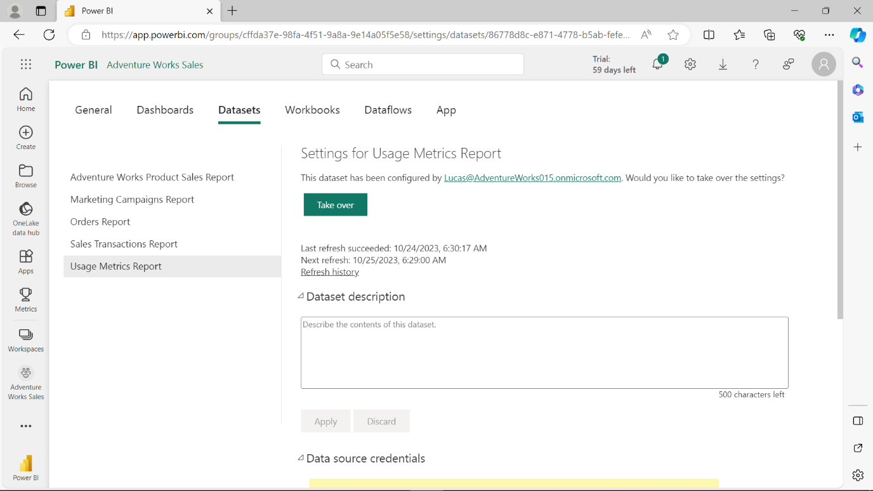

1. To update the credentials, scroll down and locate the **Data source credentials** settings. If you’re not the current dataset owner, you must take over ownership before updating the data source credentials.

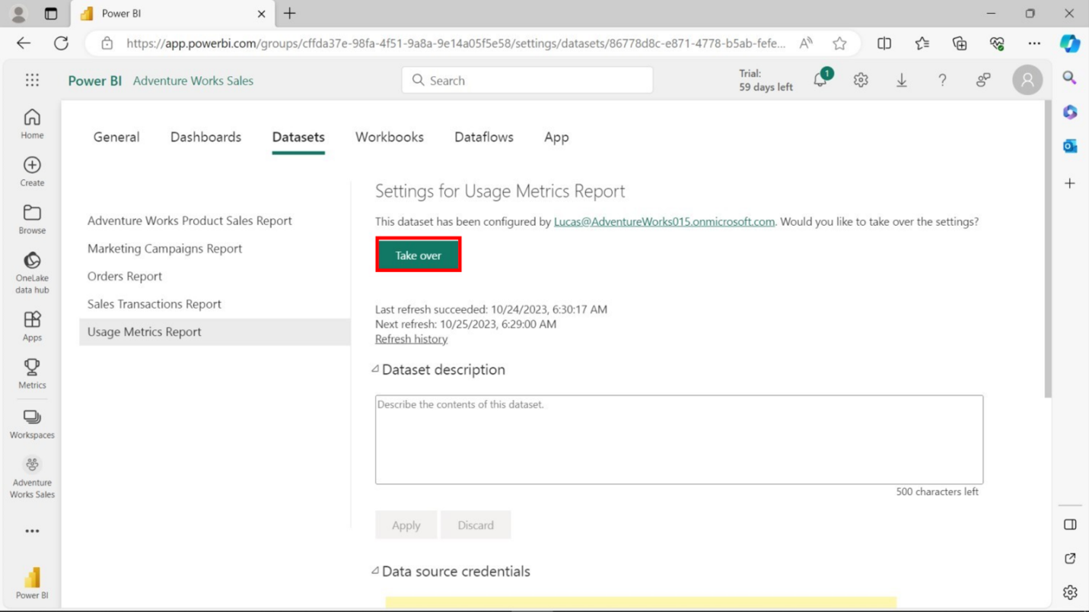

1. Select the **Take over** option to open the **Take over dataset settings** window. Select the **Take over** option again.

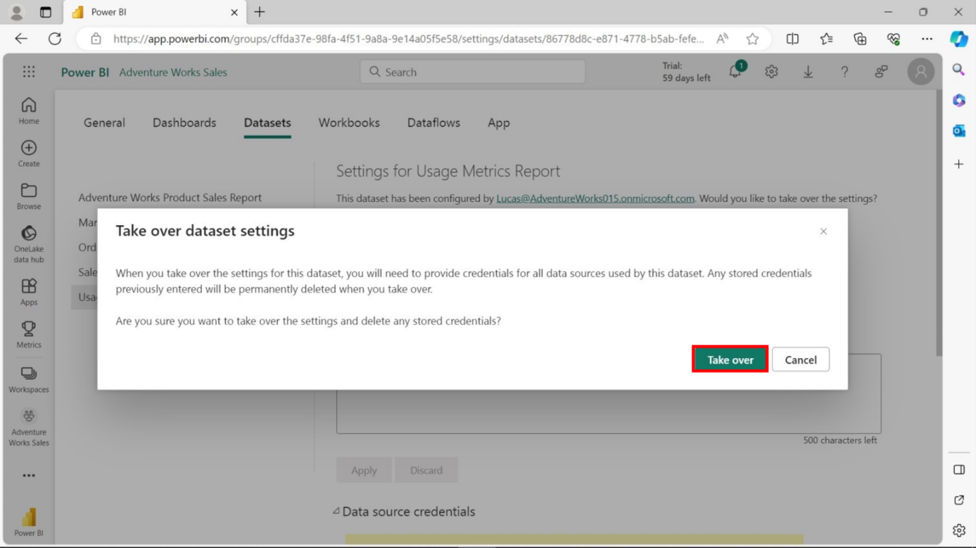

1. Then, scroll down to the **Data source credentials** settings, expand them, and select **Edit credentials** on the single connector this dataset uses.

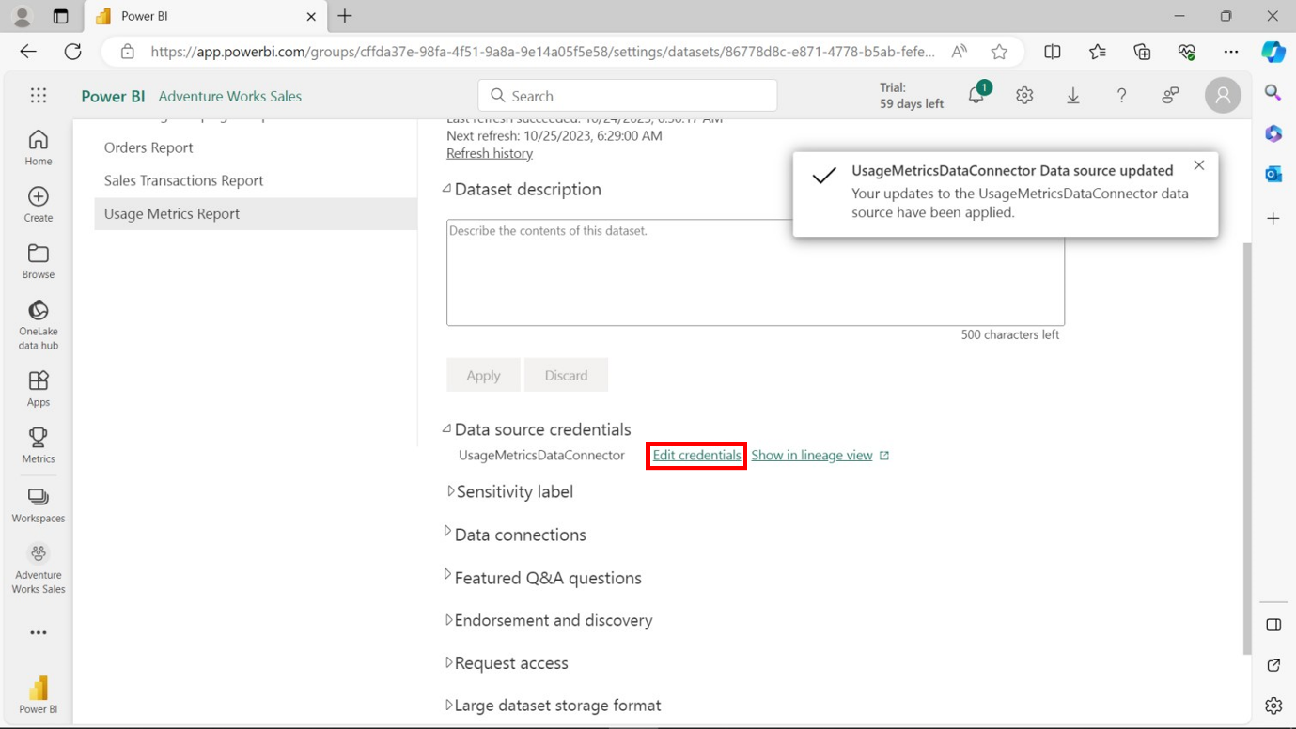

1. Sign in with your credentials and an organizational-level setting for the data source.

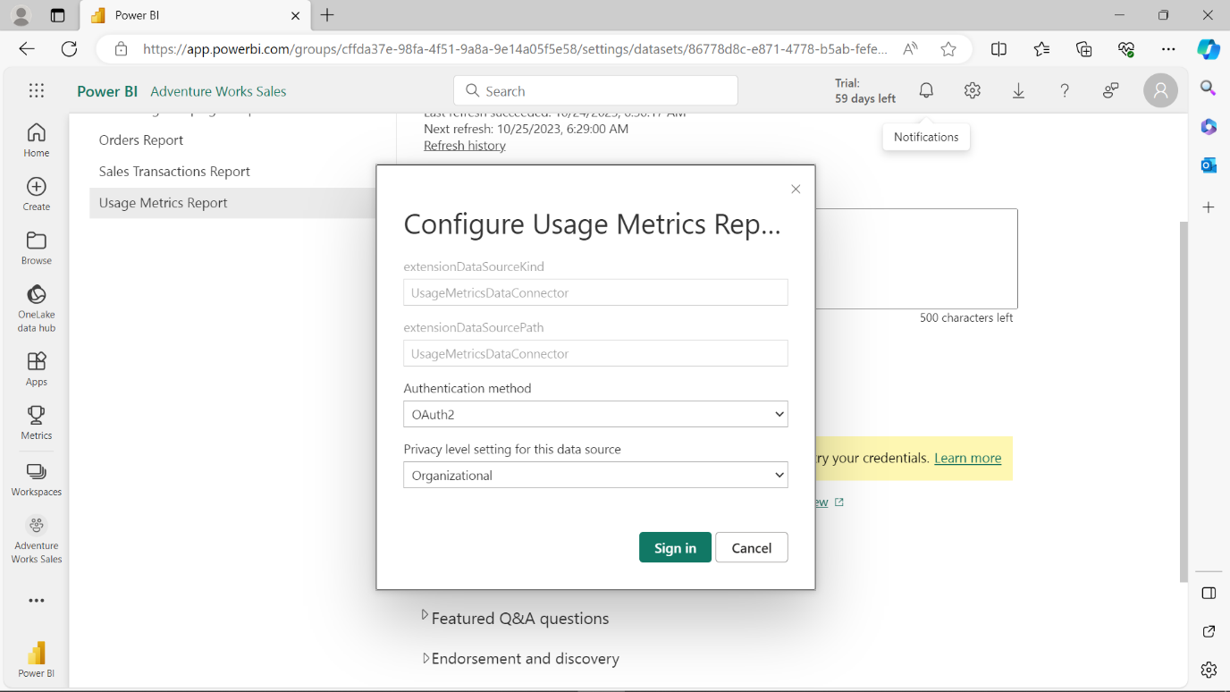

1. After a few minutes, you’ll be notified that the data source credentials were successfully updated.

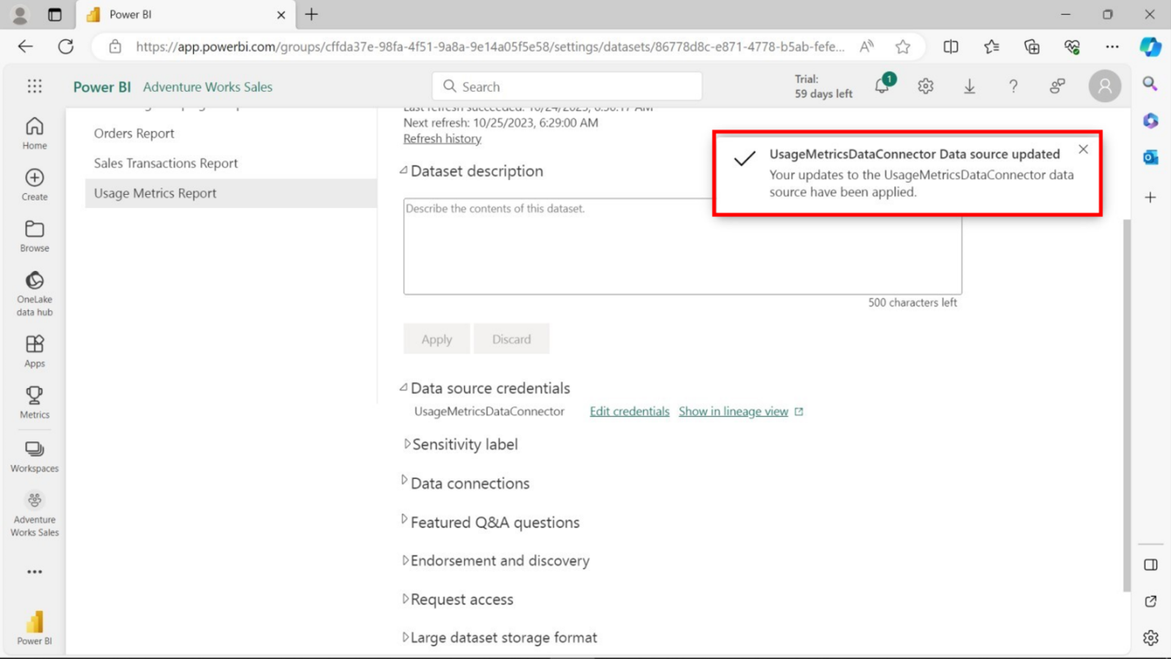

**Conclusion**

Updating report credentials in Power BI aligns with organizational policies and safeguards scheduled refresh, emphasizing the importance of credential management.